ASSIGNMENT-4

**Question 1**:

Write a code and connections in wokwi for the ultrasonic sensor. Whenever the distance is less than 100cms send an “Alert” to IBM cloud and display in the device recent events.

**Solution:**

# Coding:

#include <WiFi.h>

#include <PubSubClient.h>

WiFiClient wifiClient;

String data3;

#define ORG "w63fd1"

#define DEVICE_TYPE "JehoNi"

#define DEVICE_ID "123"

#define TOKEN "12345678"

#define speed 0.034 #define led 14 char server[] = ORG "[.messaging.internetofthings.ibmcloud.com"](http://messaging.internetofthings.ibmcloud.com/); char publishTopic[] = "iot-2/evt/Data/fmt/json"; char topic[] = "iot-2/cmd/command/fmt/String"; char authMethod[] = "use-token-auth"; char token[] = TOKEN; char clientId[] = "d:" ORG ":" DEVICE_TYPE ":" DEVICE_ID; PubSubClient client(server, 1883, wifiClient); void publishData();

const int trigpin=5; const int echopin=18; String command;

String data="";

long duration; float dist;

void setup()

{

**Serial**.begin(115200); pinMode(led, OUTPUT); pinMode(trigpin, OUTPUT); pinMode(echopin, INPUT); wifiConnect(); mqttConnect();

}

void loop() { bool isNearby = dist < 100; digitalWrite(led, isNearby);

publishData(); delay(500);

if (!client.loop()) { mqttConnect();

}

}

void wifiConnect() {

**Serial**.print("Connecting to "); **Serial**.print("Wifi"); WiFi.begin("Wokwi-GUEST", "", 6); while (WiFi.status() != WL_CONNECTED) { delay(500);

**Serial**.print(".");

}

**Serial**.print("WiFi connected, IP address: ");

**Serial**.println(WiFi.localIP());

}

void mqttConnect() { if (!client.connected()) {

**Serial**.print("Reconnecting MQTT client to "); **Serial**.println(server); while (!client.connect(clientId, authMethod, token)) { **Serial**.print("."); delay(500);

} initManagedDevice();

**Serial**.println();

}

}

void initManagedDevice() { if (client.subscribe(topic)) {

// Serial.println(client.subscribe(topic));

**Serial**.println("IBM subscribe to cmd OK");

} else {

**Serial**.println("subscribe to cmd FAILED");

} } void publishData()

{ digitalWrite(trigpin,LOW); digitalWrite(trigpin,HIGH); delayMicroseconds(10); digitalWrite(trigpin,LOW); duration=pulseIn(echopin,HIGH); dist=duration*speed/2; if(dist<100){

String payload = "{\"Normal Distance\":";

payload += dist; payload += "}";

**Serial**.print("\n");

**Serial**.print("Sending payload: "); **Serial**.println(payload); if (client.publish(publishTopic, (char*) payload.c_str())) {

**Serial**.println("Publish OK");

}

} if(dist>101 && dist<111){

String payload = "{\"Alert distance\":"; payload += dist;

payload += "}";

**Serial**.print("\n");

**Serial**.print("Sending payload: "); **Serial**.println(payload); if(client.publish(publishTopic, (char*) payload.c_str())) {

**Serial**.println("Warning crosses 110cm -- it automaticaly of the loop"); digitalWrite(led,HIGH);

}else {

**Serial**.println("Publish FAILED");

}

}

}

void callback(char* subscribeTopic, byte* payload, unsigned int payloadLength){

**Serial**.print("callback invoked for topic:");

**Serial**.println(subscribeTopic);

for(int i=0; i<payloadLength; i++){ dist += (char)payload[i];

}

**Serial**.println("data:"+ data3); if(data3=="lighton"){ **Serial**.println(data3); digitalWrite(led,HIGH);

} data3="";

}

## OUTPUT- Wokwi

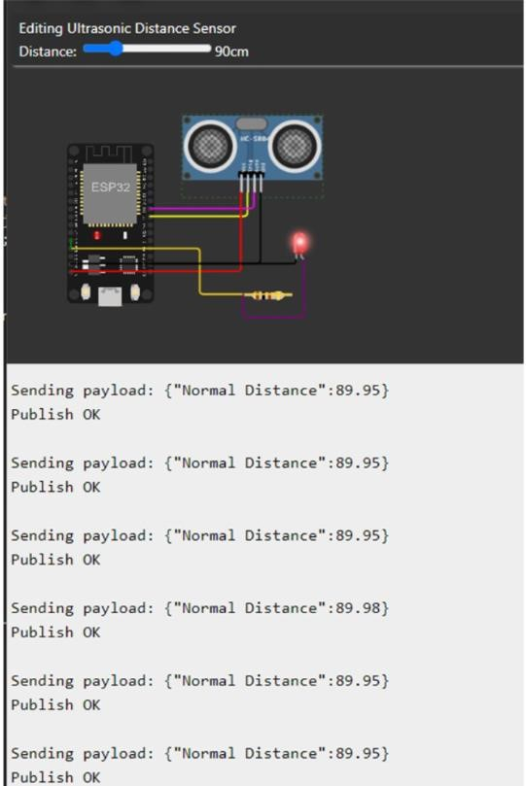

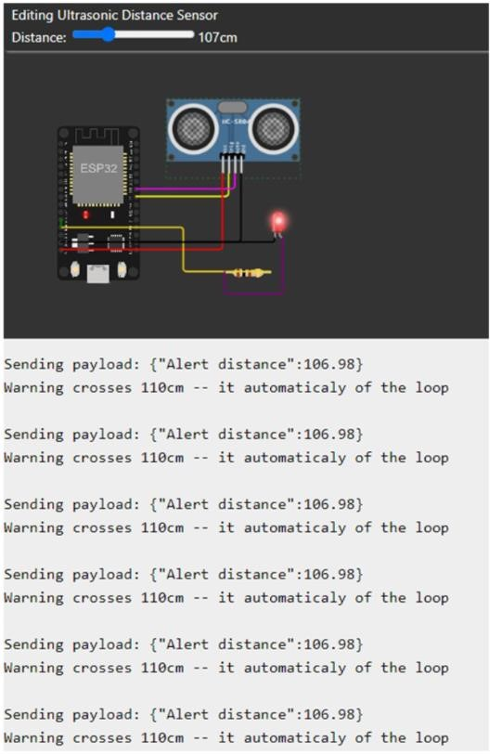

**OUTPUT-cloud**

